**API Project**

**1-create repository in git**

**2-after publish repository open it with vscode**

**3-virtualenv venv**

**source/venv/Scripts/activate**

**4-django-admin startproject cados_api**

**5-cd cados_api>python manage.py startapp base**

**6-add base app to installed apps in the settings**

**7-base app views.py:**

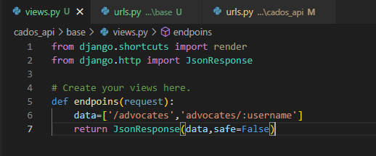

**8-base app urls.py:**

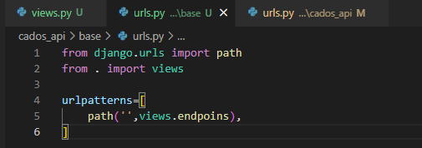

**9-cados_api urls.py:**

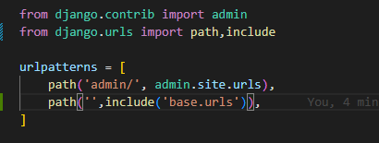

**10-Test:before test do migrate**

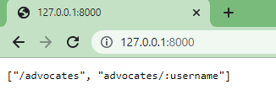

**11-base app views.py:**

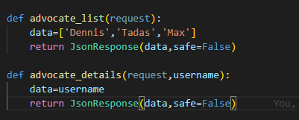

**12-base app urls.py:**

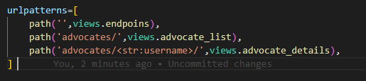

**13-Test:**

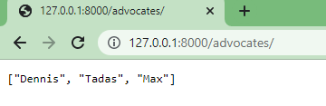

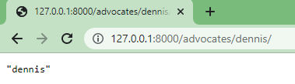

**14-django restframework:**

**pip install djangorestframework**

**then add it to installed apps in settings.py**

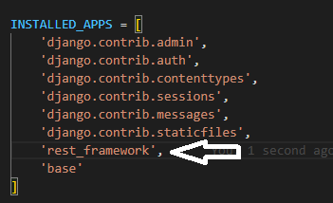

**Good site too learn:**

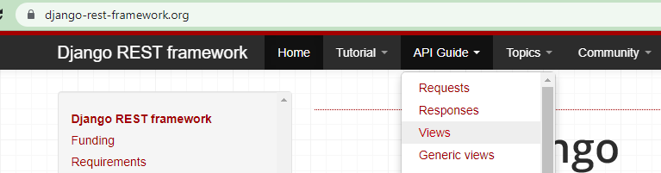

**Good example:**

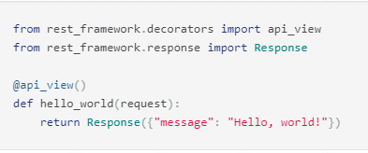

**base app view.py:**

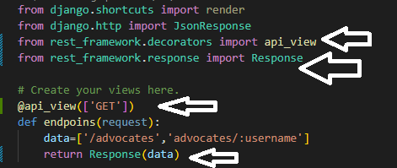

**Result:**

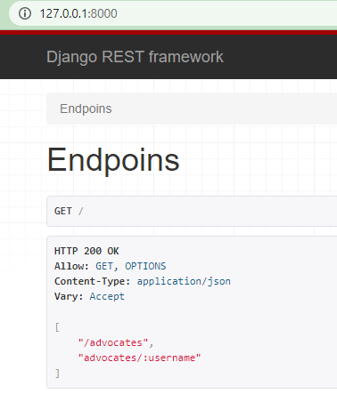

**But for teacher dosen’t work because he said he wroks with other django application and its session id cause this error and to solve it go to inspect:**

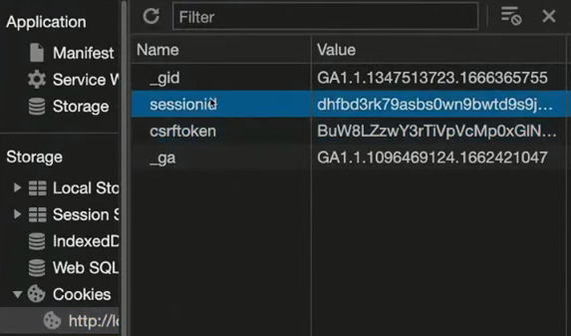

**And delete all of them:**

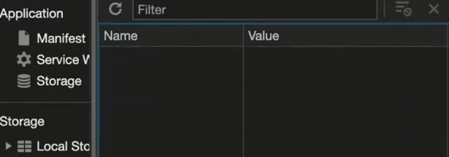

**And problem solved.**

**If we add POST request to decorator:**

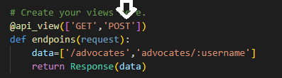

**And refresh server we see a form to send data:**

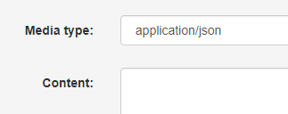



**Ao as you can see django is very powerfull and you don’t need something like postman to see rest apis.**

**15-design database in django**

**open models.py for base app:**

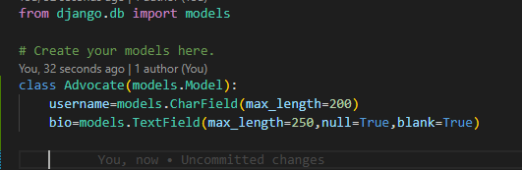

**Then migration commands**

**After it open this file:**

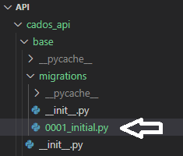

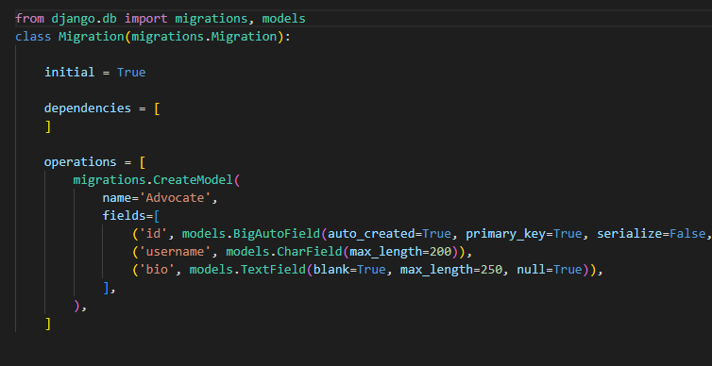

**You see it add id automatically and we don’t need to add id in models.**

**create super user to can access admin panel.after it login to admin panel.we see users and groups table here but we don’t see Advocate table.**

**admin.py base app:**

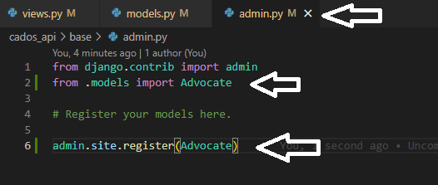

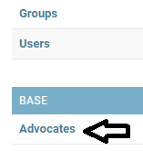

**we add 3 username:**

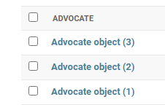

**To fix shows username instead of object:**

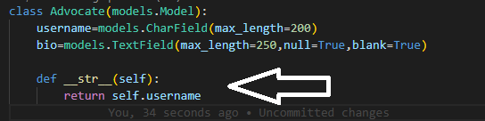

**Result:**

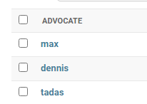

**16-another api to get all usernames**



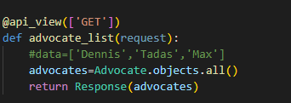

**If we runserver we have error:**

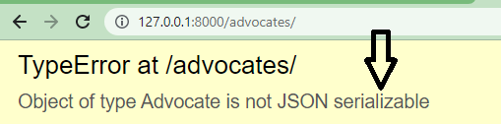

**To fix it create a new file in base app named serializers.py:**

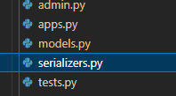

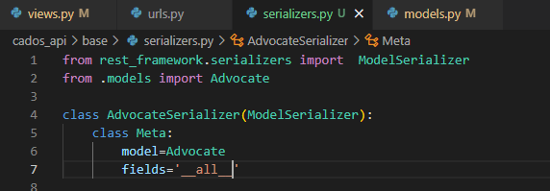

**Views.py:**



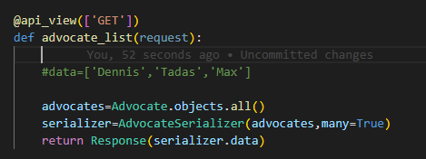

**Test:**



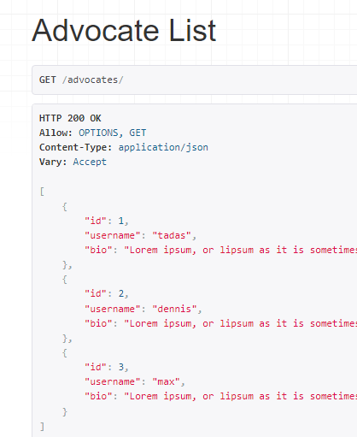

**16-another api to get 1 username**

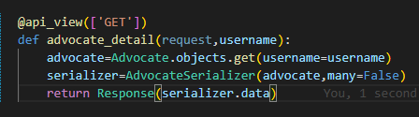



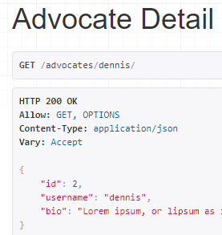

**17-get the query from the front-end to get apecific username:**

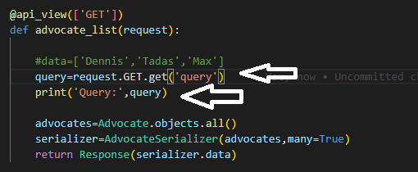

**If we run the server and go to 127.0.0.1:8000/advocates we see query is None:**



**But if we pass dennis:**





**But all usernames shows.**

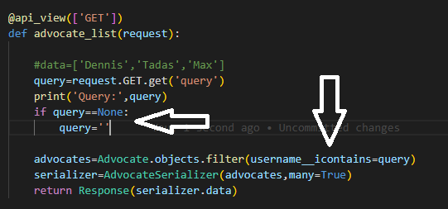



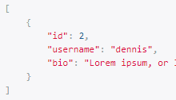

**18-two condition:**



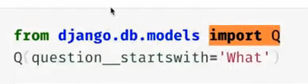



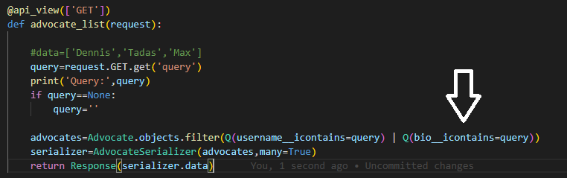



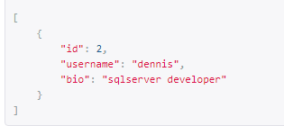

**You should know what is differenve between APIs and Rest APIs.**



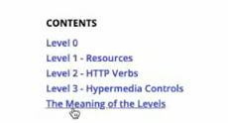

**19-handle GET and POST in one restfull API:**

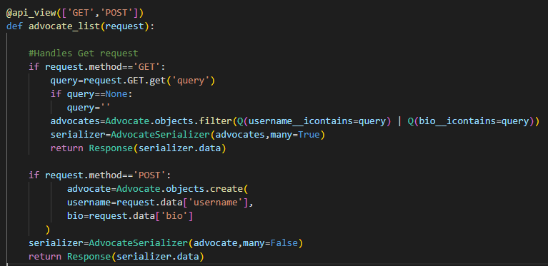

**Test:**



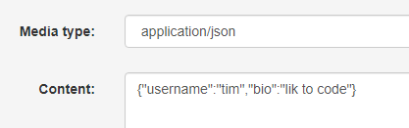



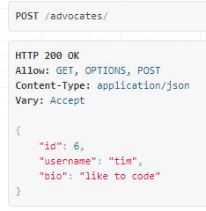

**If we refresh GET request:**



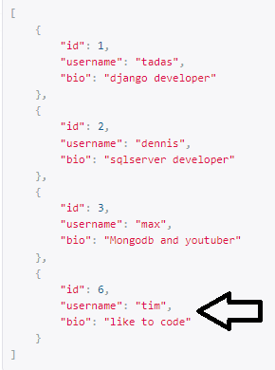

**20-GET PUT DELETE**

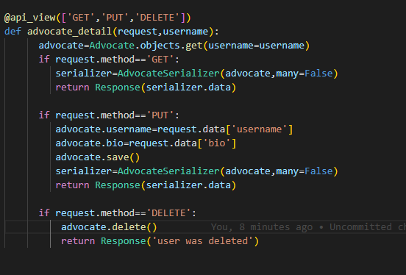

**Test:**

**Get 1 username:**



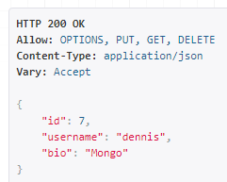

**Put:we want to change dennis informations**

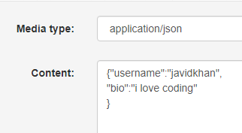



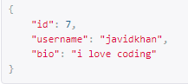

**And it works good.**

**We want to delete javidkhan username:**





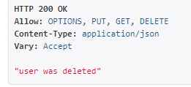

**User deleted and if we get all usernames javidkhan was deleted successfully.**

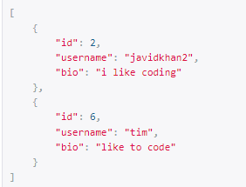

**21-rewrite advocate_detail view as class based view**

**First comment this view.and then go to this site:**



**We do need to import the APIView then pass the APIView to actuall class:**





**Then all we need to do is create a Http method.and we don’t longer to check is this a GET request or is this a POST request and we don’t need to worry about any of that.**

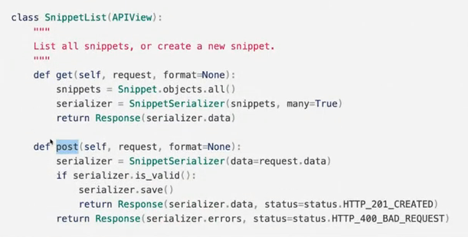

**views.py base app:**

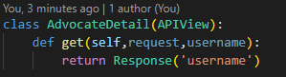

**urls.py base app:**

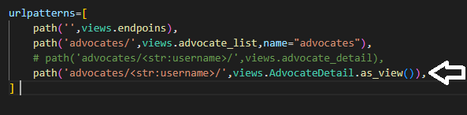

**Test:**

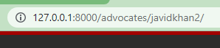

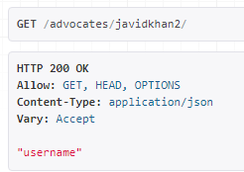

**So we complete the class based view:**

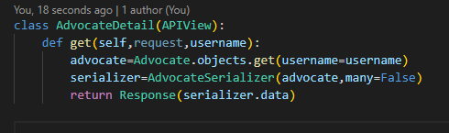

**Test:**



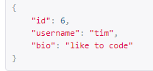

**Then we need post request:**

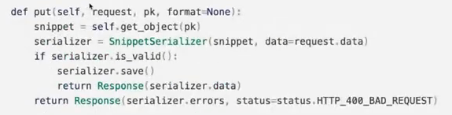

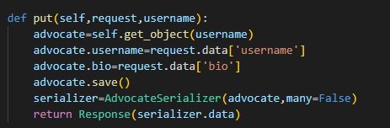

**And for delete we need to get single object:**

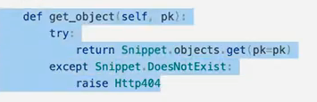

**But we modify this method and we use username instead of pk.and for call this method:**

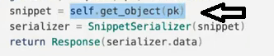

**So we change this line in get and put method:**



**To:**



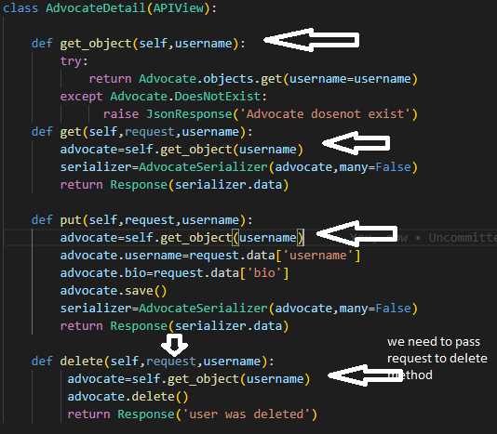

**Test:**



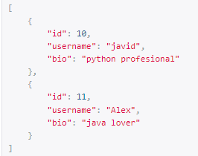



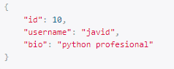



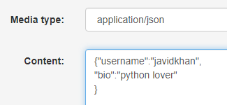

**Then put:**

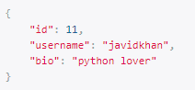

**And good work.**

**Delete Test:**



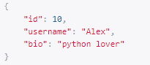



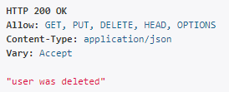



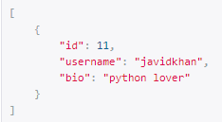

**And good work.**

**22-Relationship**

**In base app views.py create another class:**

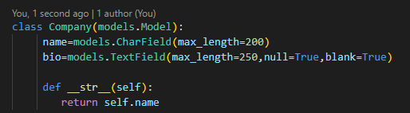

**Migrate it.**

**Admin.py:**

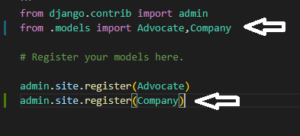

**Add 2 company in admin panel:**

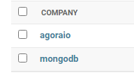

**serializer.py:**

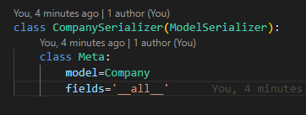

**views.py:**

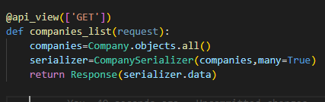

**urls.py:**

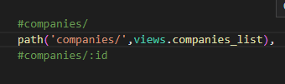

**Test:**



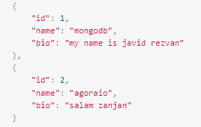

**And good work.**

**We want to make one-to-many relationship.because in real world it is possible a person works multiple companies.so we add company to Advocate model:**

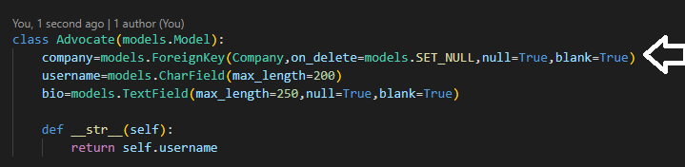

**Migrate.then in admin panel add company to persons in the Advocate table.**

**Test:**



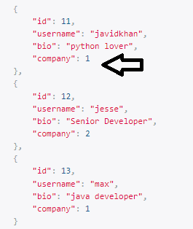

**We see company id .**

**Note:you should put company seriailizer top of the Advocate Serializer.and add this line:**

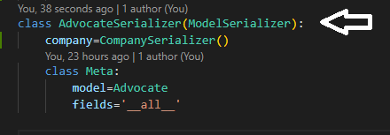

**Test:**



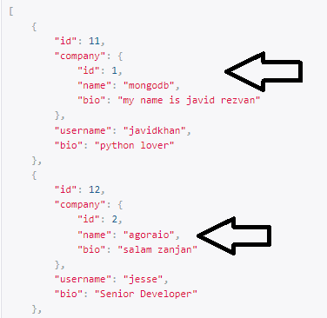

**If you change this line:**

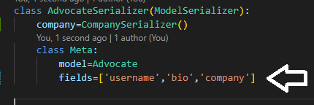

**Test:**

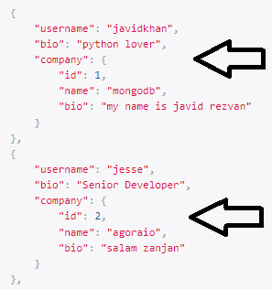

**We can add custome filed to CompanySerializer:**

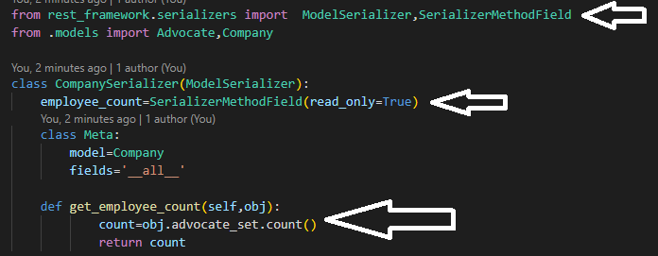

**Test:**

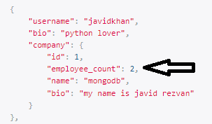

**And work good.**

**23:Authentication**

**Json Web Token**



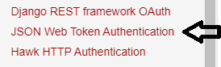

**Serach simple JWT:**

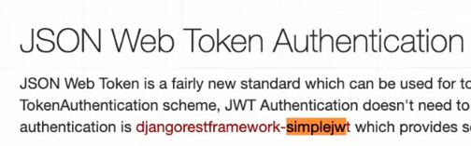



**There is a package I like to use and there is a link to official documentation.**



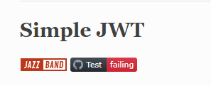

**Installation:**

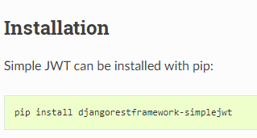

**Then we have to change authentication mechanisem in the settings.py file.so add this to settings.py:**

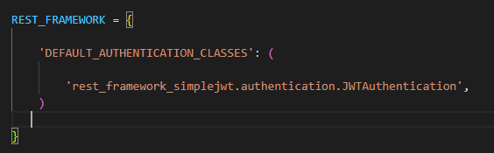



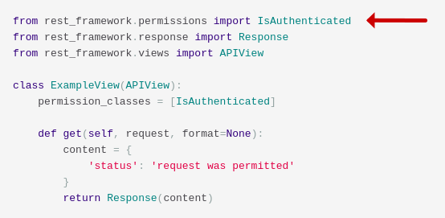

**then we import IsAuthenticated in the views.py base app:**

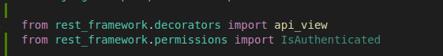

**then we have to import this:**

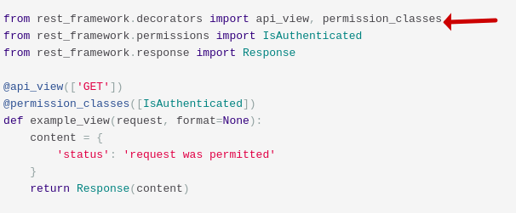

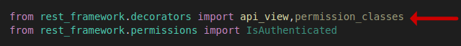**so fo each request all we gonna to do is say hey wa wanna protect le’ts say all advocate list here:**

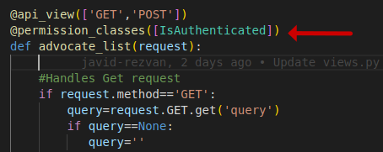

**the user has to be authenticated to see this.so if we go advocates:**

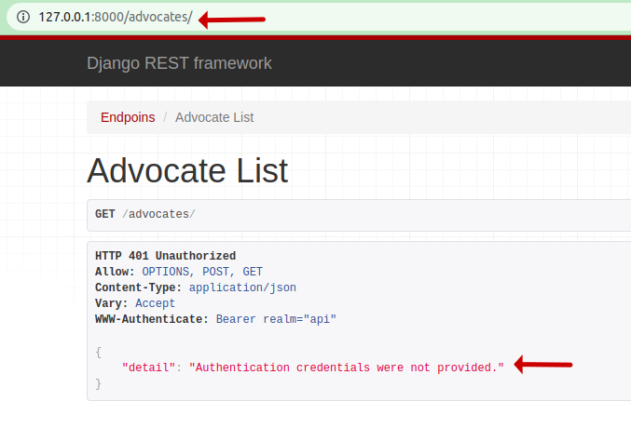

**so how to we get authenticated?first of all we need to get this token and we need to send it on every single request.**

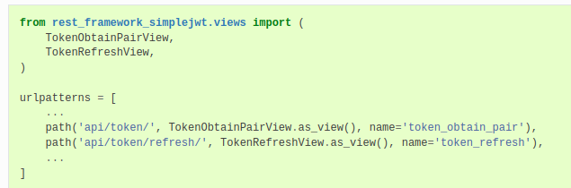

**So in urls.py base app we import just TokenObtainPairView and its url path and remove api from the path:**

**note:it is a class based view.**

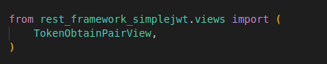

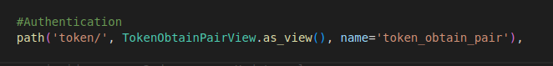**So if we gonna to go endpoint we are gonna to see a form and have the ability to actually create the token itself.**

**So if we go token url:**



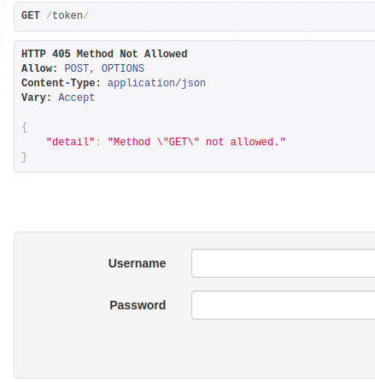



**so input admin user cerdential:**

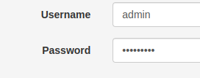

**we have access token and refresh token:**

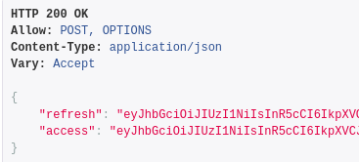

**go to JWT decoder:**



**copy access token in it:**

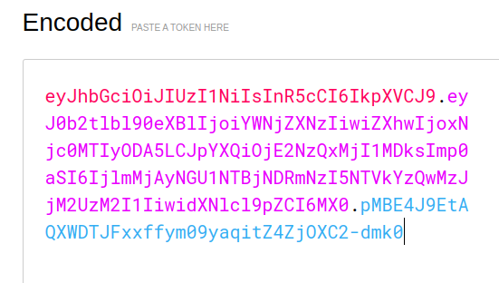

**we see all information**

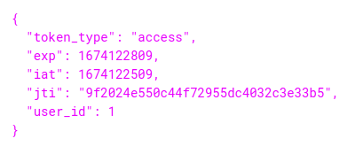

**open postman and:**



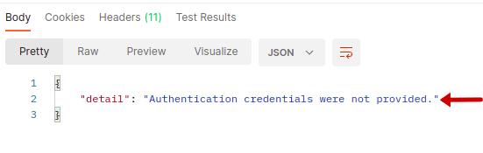

**we need t send token with request and we have access token so copy it:**

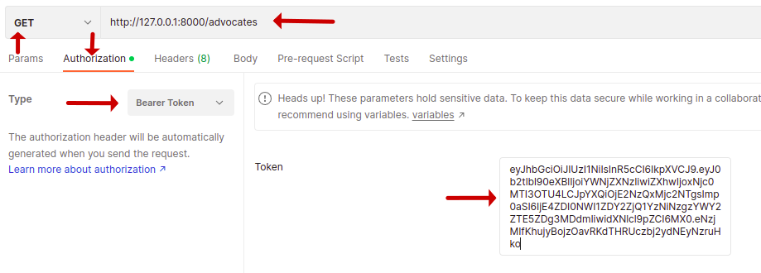

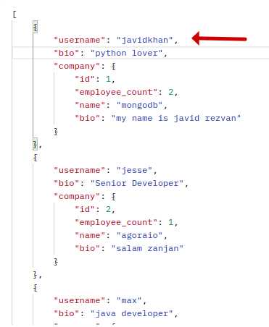

**so we passed a Bearer token and I can actually send this on every single request.one’s that token is sent in the headers I can access that data.**

**This is the default configuration for the tokens:**

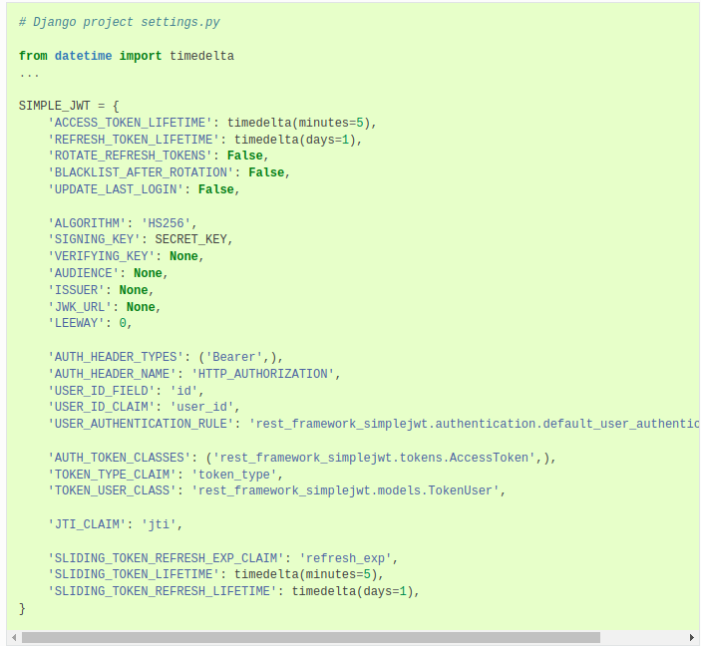

**copy these configurations to settings.py.**

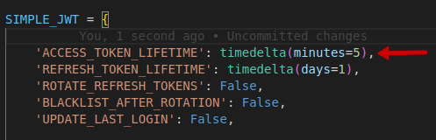

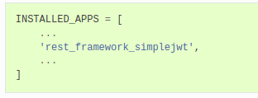**As you see life time of the access token is 5 minute.and we have to add this to installed apps:**

**add refrsh token endpoint:**

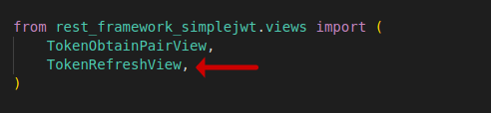

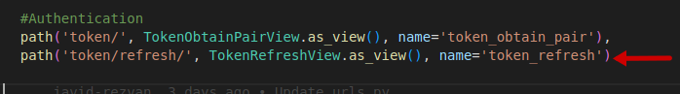**we remove api of api/token/refresh and change it to token/refresh.**

**Test:**



**the token has expired:**

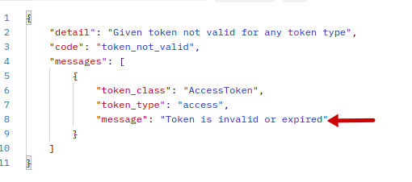

**so we need to refresh token.so copy the refrsh token:**

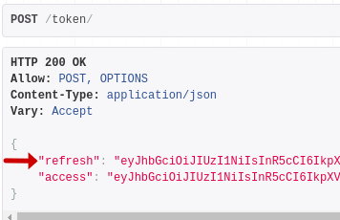

**go to this url:**



**paste refresh token here and then post it:**

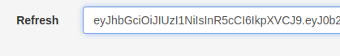

**gave us a new access token:**

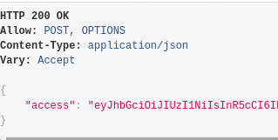

**and we can use it to accsess this endpoint in the postman**

**and we can access that endpoint:**

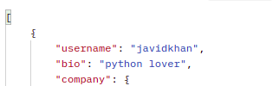

**everything is good.**

**Very important note:**

**Teacher changed access token life time to 1 second so it looks before we get access to the endpoint with that token it will expired but it worked!solution that teacher used was to unsitall djangorestframework-simplejwt and install another vesion:**

**and it worked.**

**cros-origin:**

**cross-origin resources sharing basically uh you can block other applications from requesting access to your API before you give them permission so I want to show you how to configure that.**